1. PERCEPTRON MODEL – DEBUGGING AND CONVERGENCE
A perceptron model is trained on a dataset that is known to be linearly separable, yet the algorithm fails to converge even after many iterations. Analyze the possible causes of this issue, including improper learning rate selection, incorrect weight initialization, bias handling errors, or flawed implementation of the update rule. Propose debugging strategies to identify the root cause and suggest optimization techniques to ensure faster and stable convergence.
Answer:
A perceptron should converge when the training dataset is linearly separable. If it fails to converge, the problem may be caused by incorrect parameter selection, implementation errors, or inappropriate preprocessing.
Possible Causes:
- Improper learning rate: A very high learning rate may cause unstable weight updates, while a very small learning rate can make convergence slow.
- Incorrect weight initialization: Poor initialization may delay convergence.
- Bias handling errors: If the bias is not included or updated correctly, the decision boundary may not move properly.
- Incorrect update rule: The weights should be updated only when the prediction is incorrect.
- Incorrect labels: Perceptron classification commonly uses +1 and -1; inconsistent labels can cause problems.
- Data issues: Incorrect or poorly scaled features may affect training.
Sample Dataset:
Sample | X1 | X2 | Class Y
1 | 2 | 3 | +1
2 | 3 | 4 | +1
3 | 4 | 2 | +1
4 | 1 | 1 | -1
5 | 2 | 1 | -1
6 | 1 | 2 | -1

CODE:
import numpy as np
X = np.array([ [2, 3], [3, 4], [4, 2], [1, 1], [2, 1], [1, 2]])
y = np.array([1, 1, 1, -1, -1, -1])
learning_rate = 0.1
epochs = 20
weights = np.zeros(X.shape[1])
bias = 0
print("Initial Weights:", weights)
print("Initial Bias:", bias)
for epoch in range(epochs):
errors = 0
print("\nEpoch", epoch + 1)
for i in range(len(X)):
net_input = np.dot(X[i], weights) + bias
prediction = 1 if net_input >= 0 else -1
if prediction != y[i]:
weights = weights + learning_rate * y[i] * X[i]
bias = bias + learning_rate * y[i]
errors += 1
print("Input:", X[i],
"Target:", y[i],
"Prediction:", prediction)
print("Updated Weights:", weights)
print("Updated Bias:", bias)
print("Errors:", errors)
if errors == 0:
print("\nPerceptron Converged Successfully!")
break
print("\nTraining Completed")
print("Final Weights:", weights)
print("Final Bias:", bias)
print("\nTesting on Training Data")
for i in range(len(X)):
net = np.dot(X[i], weights) + bias
pred = 1 if net >= 0 else -1
print("Input:", X[i],
"Actual:", y[i],
"Predicted:", pred)

OUTPUT:
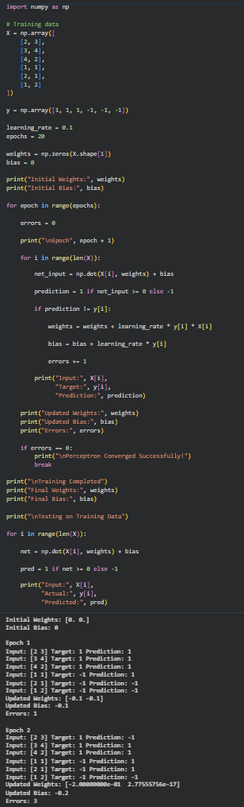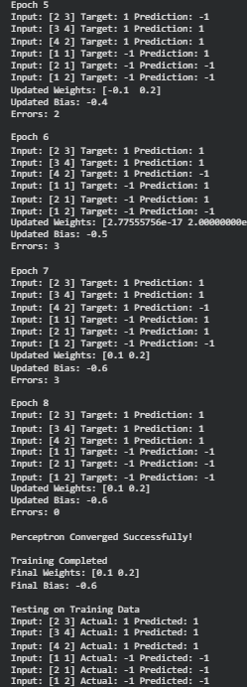

2. MULTILAYER PERCEPTRON – BACKPROPAGATION
While training a multilayer perceptron using the backpropagation algorithm, the network exhibits slow convergence and gets stuck in local minima. Examine the potential reasons such as vanishing gradients, inappropriate activation functions, poor weight initialization, or suboptimal learning rates. Describe step-by-step debugging approaches to trace the issue and recommend optimization techniques like adaptive learning rates, normalization, or advanced optimizers to improve performance. (5 Marks)
Answer:
A multilayer perceptron may converge slowly or get stuck due to problems in gradient calculation, activation functions, initialization, or learning-rate selection.
Possible Reasons:
- Vanishing gradients: Gradients can become extremely small during backpropagation.
- Inappropriate activation functions: Sigmoid or tanh in many hidden layers may slow learning.
- Poor weight initialization: Large or poorly selected weights can make training unstable.
- Learning rate: A very small rate causes slow learning, while a very large rate may overshoot the minimum.
- Unnormalized data: Features with different scales can make optimization difficult.
- Local minima / saddle points: Optimization may become trapped in poor regions of the loss surface.
Sample Dataset:
X1 | X2 | Target
0 | 0 | 0
0 | 1 | 1
1 | 0 | 1
1 | 1 | 0
This is the XOR problem, which cannot be solved by a single perceptron but can be solved using an MLP.
CODE:
import numpy as np
X = np.array([ [0, 0],[0, 1], [1, 0], [1, 1]], dtype=float)
y = np.array([ [0],[1], [1],[0]], dtype=float)
np.random.seed(42)
W1 = np.random.randn(2, 4) * 0.5
b1 = np.zeros((1, 4))
W2 = np.random.randn(4, 1) * 0.5
b2 = np.zeros((1, 1))
learning_rate = 0.5
epochs = 10000
def sigmoid(x):
return 1 / (1 + np.exp(-x))
def sigmoid_derivative(x):
return x * (1 - x)
for epoch in range(epochs):
# Forward propagation
z1 = np.dot(X, W1) + b1
a1 = sigmoid(z1)
z2 = np.dot(a1, W2) + b2
output = sigmoid(z2)
# Error
error = y - output
# Backpropagation
d_output = error * sigmoid_derivative(output)
error_hidden = np.dot(d_output, W2.T)
d_hidden = error_hidden * sigmoid_derivative(a1)
# Update weights
W2 += learning_rate * np.dot(a1.T, d_output)
b2 += learning_rate * np.sum(d_output, axis=0, keepdims=True)
W1 += learning_rate * np.dot(X.T, d_hidden)
b1 += learning_rate * np.sum(d_hidden, axis=0, keepdims=True)
if epoch % 1000 == 0:
loss = np.mean(error ** 2)
print("Epoch:", epoch, "Loss:", loss)
# Testing
print("\nFinal Predictions:")
for i in range(len(X)):
z1 = np.dot(X[i], W1) + b1
a1 = sigmoid(z1)
z2 = np.dot(a1, W2) + b2
prediction = sigmoid(z2)
print(
"Input:", X[i],
"Actual:", int(y[i][0]),
"Predicted:", round(float(prediction[0]), 3)
)
OUTPUT:
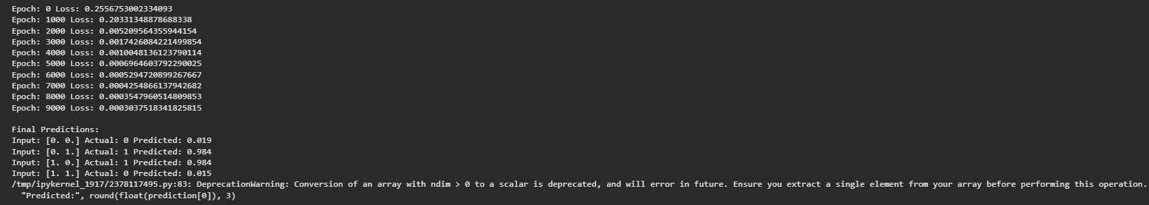

3.GENETIC ALGORITHM – HYPOTHESIS SPACE SEARCH
A genetic algorithm designed for hypothesis space search is producing inconsistent and suboptimal solutions across multiple runs. Investigate possible issues such as improper encoding of chromosomes, incorrect fitness function design, premature convergence, or lack of diversity in the population. Explain how to debug these problems systematically and suggest optimization strategies like mutation tuning, selection pressure adjustment, and elitism to enhance solution quality and convergence speed.
Answer:
A genetic algorithm uses a population of candidate solutions and evolves them using selection, crossover, and mutation. Inconsistent results may occur because of poor chromosome representation, inappropriate fitness functions, excessive selection pressure, or insufficient population diversity.
Possible Causes:
- Improper chromosome encoding: The chromosome may not correctly represent the hypothesis.
- Incorrect fitness function: A poorly designed fitness function may reward unsuitable solutions.
- Premature convergence: The population may become too similar too early.
- Low diversity: Insufficient mutation can cause the algorithm to explore only a small part of the search space.
- Excessive selection pressure: Strong selection may eliminate useful genetic variations.
- Poor crossover/mutation rates: Incorrect probabilities can negatively affect exploration.
Sample Problem:
Find a binary chromosome containing four 1s.
Target:
1111
CODE:
import random
random.seed(42)
POPULATION_SIZE = 10
CHROMOSOME_LENGTH = 4
GENERATIONS = 20
MUTATION_RATE = 0.1
def create_chromosome():
return [
random.randint(0, 1)
for _ in range(CHROMOSOME_LENGTH)
]
def fitness(chromosome):
return sum(chromosome)
def selection(population):
population.sort(key=fitness, reverse=True)
return population[:2]
def crossover(parent1, parent2):
point = random.randint(1, CHROMOSOME_LENGTH - 1
child1 = parent1[:point] + parent2[point:
child2 = parent2[:point] + parent1[point:]
return child1, child2
def mutation(chromosome):
for i in range(len(chromosome)):
if random.random() < MUTATION_RATE:
chromosome[i] = 1 - chromosome[i]
return chromosome
# Initial population
population = [
create_chromosome()
for _ in range(POPULATION_SIZE)
]
for generation in range(GENERATIONS):
population.sort(key=fitness, reverse=True)
best = population[0]
print(
"Generation:", generation + 1,
"Best:", best,
"Fitness:", fitness(best)
)
if fitness(best) == CHROMOSOME_LENGTH:
print("\nOptimal solution found!")
break
# Elitism
new_population = [best.copy()]
parents = selection(population)
while len(new_population) < POPULATION_SIZE:
parent1 = random.choice(parents)
parent2 = random.choice(parents)
child1, child2 = crossover(parent1, parent2)
child1 = mutation(child1)
child2 = mutation(child2)
new_population.append(child1)

if len(new_population) < POPULATION_SIZE:
new_population.append(child2)
population = new_population
print("\nFinal Solution:", population[0])
print("Final Fitness:", fitness(population[0]))
OUTPUT:

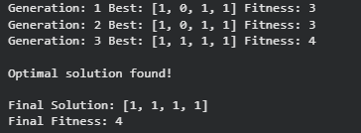

4. CNN – IMAGE CLASSIFICATION
Question 4
A convolutional neural network (CNN) used for image classification produces unstable results across training epochs. Examine potential issues such as improper data augmentation, vanishing gradients, or batch normalization errors. Describe debugging strategies and suggest optimization techniques to stabilize training and improve accuracy. (5 Marks)
Answer:
A CNN may produce unstable training results when the input data, network architecture, normalization, or optimization parameters are not properly configured.
Possible Causes:
- Improper data augmentation: Excessive or incorrect transformations can change important image features.
- Vanishing gradients: Deep networks may experience very small gradients.
- Batch normalization errors: Incorrect placement or configuration can destabilize training.
- Large learning rate: The optimizer may overshoot the minimum.
- Poor preprocessing: Images should be consistently scaled and normalized.
- Overfitting: The model may perform well on training data but poorly on validation data.
- Poor initialization: Incorrect initialization may make training unstable.

Sample Dataset:
For demonstration, the MNIST handwritten digit dataset can be used.
CODE:
import tensorflow as tf
from tensorflow.keras import layers, models
# Load MNIST dataset
(x_train, y_train), (x_test, y_test) = \
tf.keras.datasets.mnist.load_data()
# Normalize images
x_train = x_train.astype("float32") / 255.0
x_test = x_test.astype("float32") / 255.0
# Add channel dimension
x_train = x_train[..., None]
x_test = x_test[..., None]
# CNN model
model = models.Sequential([
layers.Conv2D(
32,
(3, 3),
activation="relu",
input_shape=(28, 28, 1)
),
layers.BatchNormalization(),
layers.MaxPooling2D((2, 2)),
layers.Conv2D(
64,
(3, 3),
activation="relu"
),
layers.BatchNormalization(),
layers.MaxPooling2D((2, 2)),
layers.Flatten(),
layers.Dense(128, activation="relu"),
layers.Dropout(0.3),
layers.Dense(10, activation="softmax")
])

# Compile
model.compile(
optimizer=tf.keras.optimizers.Adam(
learning_rate=0.001
),
loss="sparse_categorical_crossentropy",
metrics=["accuracy"]
)
# Train
history = model.fit(
x_train,
y_train,
epochs=5,
batch_size=64,
validation_split=0.1
)
# Evaluate
test_loss, test_accuracy = model.evaluate(
x_test,
y_test,
verbose=0
)
print("\nTest Loss:", round(test_loss, 4))
print("Test Accuracy:", round(test_accuracy, 4))

OUTPUT:
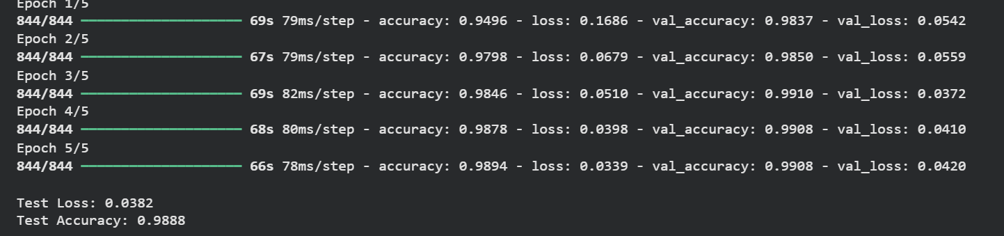

5. NAIVE BAYES – TEXT CLASSIFICATION
Question 5
A Naïve Bayes classifier used for text classification performs poorly when applied to real-world data containing noisy and irrelevant features. Examine possible issues such as violation of feature independence assumption, improper preprocessing, or imbalanced dataset. Explain debugging strategies and suggest improvements like feature selection, smoothing techniques, and data balancing methods. (5 Marks)
Answer:
Naïve Bayes is a simple and effective classification algorithm for text data. However, its performance can decrease when the dataset contains irrelevant features, noise, class imbalance, or preprocessing errors.
Possible Causes:
- Violation of independence assumption: Naïve Bayes assumes that features are conditionally independent.
- Noisy features: Irrelevant words can reduce classification performance.
- Improper preprocessing: Stop words, punctuation, URLs, and unnecessary symbols can introduce noise.
- Class imbalance: A classifier may favor the majority class.
- Zero-frequency problem: A word that does not appear in a particular class may result in zero probability.
- Small training dataset: Insufficient examples may produce poor probability estimates.
Sample Dataset:
Text | Class
I love this movie | Positive
Excellent and wonderful film | Positive
This movie is amazing | Positive
I hate this movie | Negative
Very bad and boring film | Negative
Terrible movie experience | Negative
CODE:
from sklearn.feature_extraction.text import TfidfVectorizer
from sklearn.naive_bayes import MultinomialNB
from sklearn.pipeline import Pipeline
from sklearn.model_selection import train_test_split
from sklearn.metrics import accuracy_score, classification_report
texts = [
"I love this movie",
"Excellent and wonderful film",
"This movie is amazing",
"I really enjoyed this film",
"Fantastic and great movie",
"I hate this movie",
"Very bad and boring film",
"Terrible movie experience",
"This film is awful",
"I dislike this movie",
"Bad acting and poor story",
"Worst movie ever"
]
labels = [
"Positive",
"Positive",
"Positive",
"Positive",
"Positive",
"Negative",
"Negative",
"Negative",
"Negative",
"Negative",
"Negative",
"Negative"
]
# Split dataset
X_train, X_test, y_train, y_test = train_test_split(
texts,
labels,
test_size=0.25,
random_state=42,
stratify=labels
)
# Pipeline
model = Pipeline([
(
"tfidf",
TfidfVectorizer(
stop_words="english",
max_features=1000 )),
(
"classifier",
MultinomialNB(alpha=1.0)
)
])

# Train
model.fit(X_train, y_train)
# Prediction
predictions = model.predict(X_test)
# Evaluation
print("Predictions:", predictions)
print("\nActual:", list(y_test))
print(
"\nAccuracy:",
round(accuracy_score(y_test, predictions), 2)
)
print("\nClassification Report:")
print(
classification_report(
y_test,
predictions,
zero_division=0
)
)
# Test new text
new_text = [
"This movie was excellent and amazing",
"The film was terrible and boring"
]
new_predictions = model.predict(new_text)
print("\nNew Text Predictions:")
for text, prediction in zip(
new_text,
new_predictions
):
print(text, "->", prediction)
OUTPUT:
